  - Agile Product Development using Jira and Jenkins

Smart Complaint and Maintenance Portal
By: Sayali Rajput and Mayank Sawant
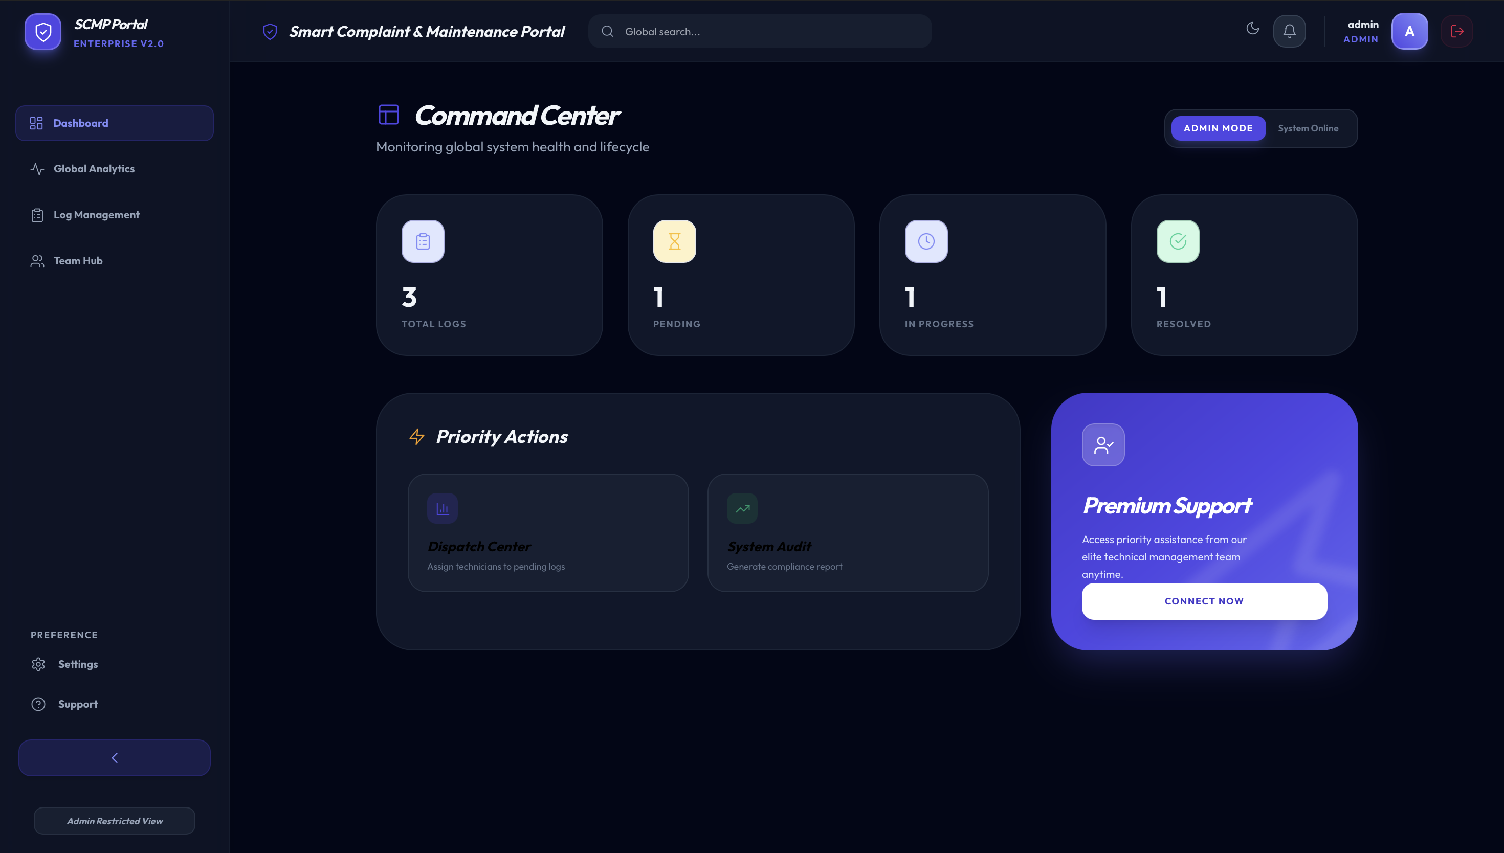

INDEX
Sr. No. | Content | Page No.
1 | Abstract | 3
2 | Introduction | 4
3 | Problem Statement | 5
4 | Objectives | 5
5 | System Overview | 6
6 | Agile Development Methodology | 7
7 | Sprint Planning and Implementation | 9
8 | DevOps Implementation using Jenkins | 12
9 | System Architecture | 14
10 | Key Features of the System | 15
11 | Advantages of the System | 16
12 | Limitations of the System | 16
13 | Technology Stack | 17
14 | Use Case Diagram | 28
15 | Database Design / ER Diagram | 20
16 | User Interface Screenshots | 22
17 | Testing | 30
18 | Future Enhancements | 31
19 | Conclusion | 32

Abstract
The Smart Complaint and Maintenance Portal (SCMP) is a web-based system designed to streamline complaint registration, tracking, and resolution within an organization. The platform enables users to submit maintenance requests while allowing technicians and administrators to manage and monitor complaint workflows efficiently.
The project was developed using Agile Product Development methodology, where the system was divided into multiple development sprints managed through Jira. Each sprint focused on delivering specific features such as authentication, complaint management, technician task handling, and system analytics.
To support modern DevOps practices, Jenkins was integrated as a Continuous Integration (CI) tool. Jenkins automated the build process and monitored system performance through build pipelines and build time trends, ensuring reliable and efficient deployment.
The system includes role-based dashboards for Users, Technicians, and Administrators, enabling efficient maintenance request handling. Users can submit complaints, technicians can update repair progress, and administrators can monitor system analytics and complaint distribution.
By integrating Agile project management and DevOps automation, the Smart Complaint and Maintenance Portal improves transparency, reduces complaint resolution time, and provides an efficient maintenance management platform.

Introduction
In many organizations, institutions, and campuses, maintenance issues such as electrical faults, equipment failures, water leakages, or system malfunctions are usually reported through manual methods like phone calls, emails, or physical complaint registers. These traditional methods often lead to problems such as delayed responses, lack of transparency, poor tracking of complaint status, and inefficient communication between users and maintenance staff.
To address these challenges, the Smart Complaint and Maintenance Portal (SCMP) was developed as a centralized digital platform that allows users to report issues and track their progress in real time. The portal enables maintenance staff and administrators to efficiently manage complaints, assign tasks, monitor system performance, and ensure timely resolution of issues.
The system is designed as a web-based application with role-based access control, where different users interact with the system based on their responsibilities. Regular users can submit complaints and monitor their status, technicians can manage assigned repair tasks, and administrators can oversee the entire complaint management process through analytics dashboards.
The development of this system follows the Agile Product Development methodology, which focuses on iterative development, continuous feedback, and incremental delivery of features. The project was divided into multiple sprints using Jira, allowing the development team to plan tasks, track progress, and manage the product backlog effectively.
Additionally, DevOps practices were incorporated to improve development efficiency and automation. Jenkins was used as a Continuous Integration (CI) tool to automate builds and monitor build performance through a build pipeline. This integration ensures faster development cycles, early detection of errors, and reliable deployment.
The Smart Complaint and Maintenance Portal not only simplifies complaint management but also demonstrates how Agile methodology and DevOps tools can be effectively combined to build scalable and efficient software systems.

Problem Statement
In many organizations, maintenance issues are reported through manual methods such as phone calls or complaint registers. These methods often cause delays, poor tracking, and lack of transparency in resolving issues.
There is no centralized system to monitor complaint status, assign tasks to technicians, or analyze maintenance performance. This leads to inefficient communication and slower problem resolution.
Therefore, a Smart Complaint and Maintenance Portal is required to provide a centralized platform where users can submit complaints, technicians can manage repair tasks, and administrators can monitor the entire maintenance workflow efficiently using Agile development with Jira and CI/CD automation using Jenkins.

Objectives
The main objectives of the Smart Complaint and Maintenance Portal are:
- To develop a centralized system for submitting and managing maintenance complaints.
- To allow users to track the status of their complaints easily.
- To help technicians manage assigned repair tasks efficiently.
- To provide administrators with dashboards and complaint analytics.
- To implement Agile development using Jira for sprint planning and task management.
- To integrate Jenkins for Continuous Integration (CI) and automated build monitoring.

System Overview
The Smart Complaint and Maintenance Portal is a web based system designed to simplify the process of reporting and resolving maintenance issues. The system provides a centralized platform where users can submit complaints and track their status while technicians and administrators manage the repair process.
The portal works through three main roles:
User:
Users can register and log into the portal to submit maintenance complaints. They can track the status of their complaints, view previous requests, and monitor updates on repair progress.
Technician:
Technicians receive assigned complaints from the administrator. They can view tasks, update repair progress, and mark complaints as resolved once the issue has been fixed.
Administrator:
The administrator manages the overall system. The admin can view all complaints, assign tasks to technicians, monitor complaint statistics, and analyze system performance through dashboards and reports.
This role based structure ensures efficient management of complaints and smooth communication between users, technicians, and administrators.

Agile Development Methodology
The Smart Complaint and Maintenance Portal was developed using the Agile Product Development methodology, specifically following the Scrum framework. Agile allows the development team to build the system in small increments called sprints, making it easier to add features, test functionality, and improve the system continuously.
In this project, Jira was used as the Agile project management tool to organize tasks, manage the product backlog, and track sprint progress.
The development process included the following Agile practices:
Product Backlog:
All project features such as authentication, complaint management, technician tasks, and admin dashboard were listed as backlog items in Jira.
Sprint Planning:
Tasks from the backlog were selected and assigned to specific sprints for development.
Sprint Execution:
Each sprint focused on implementing a set of features within a fixed time period.
Task Tracking:
Jira boards were used to track tasks using different stages such as To Do, In Progress, and Done.
Using Agile methodology helped the team develop the system in an organized and flexible manner while continuously improving the product.

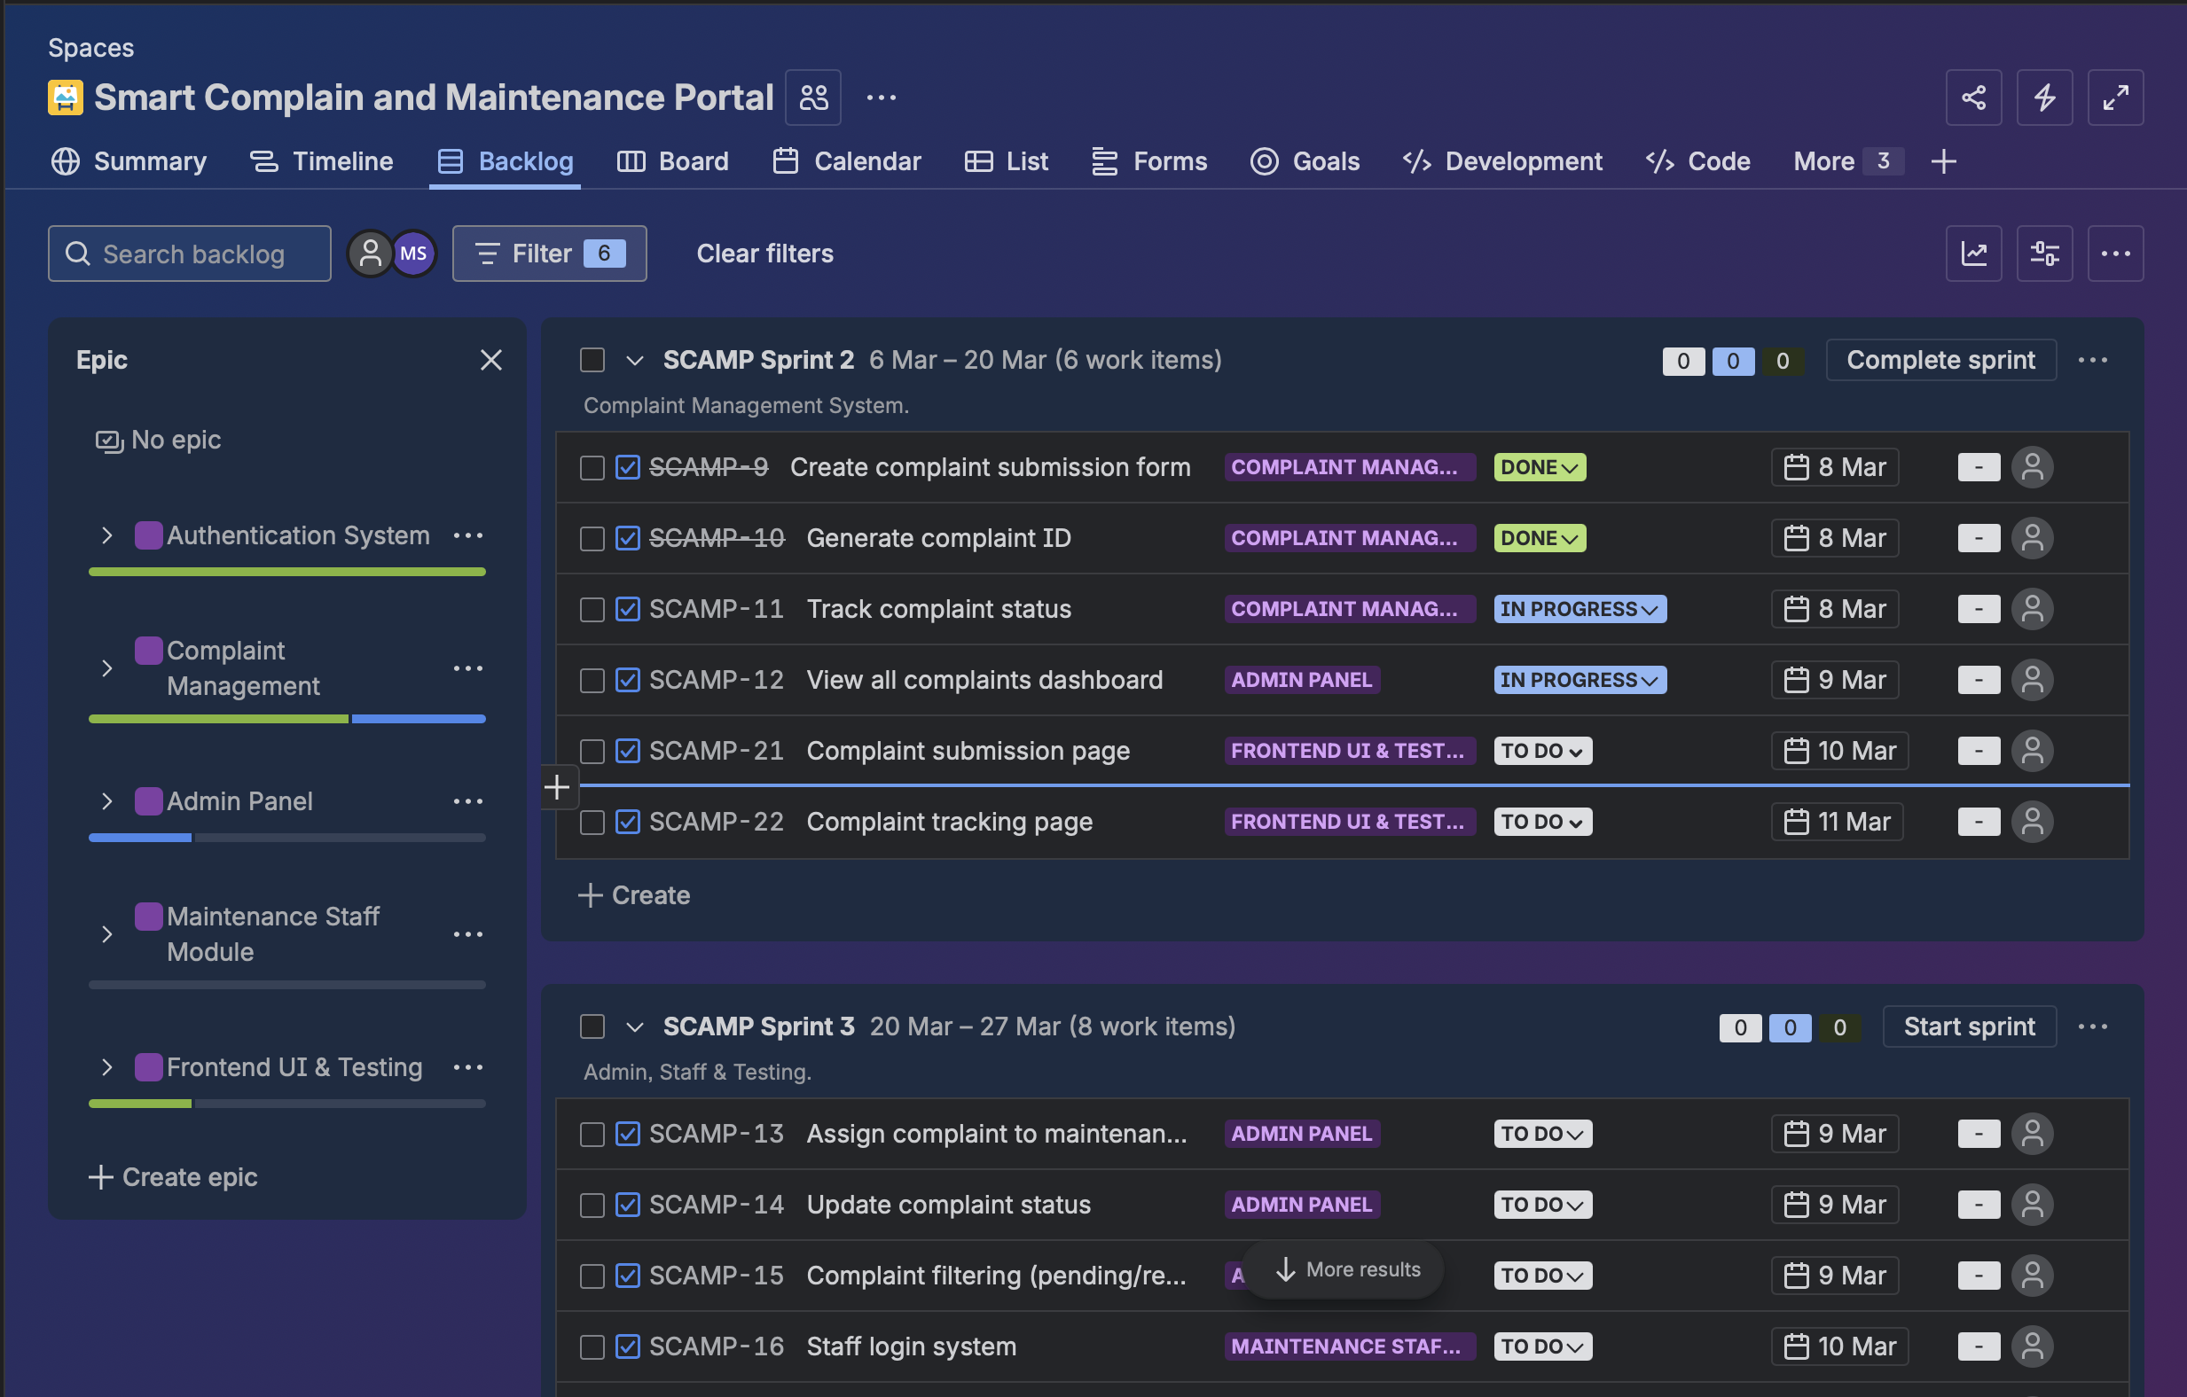
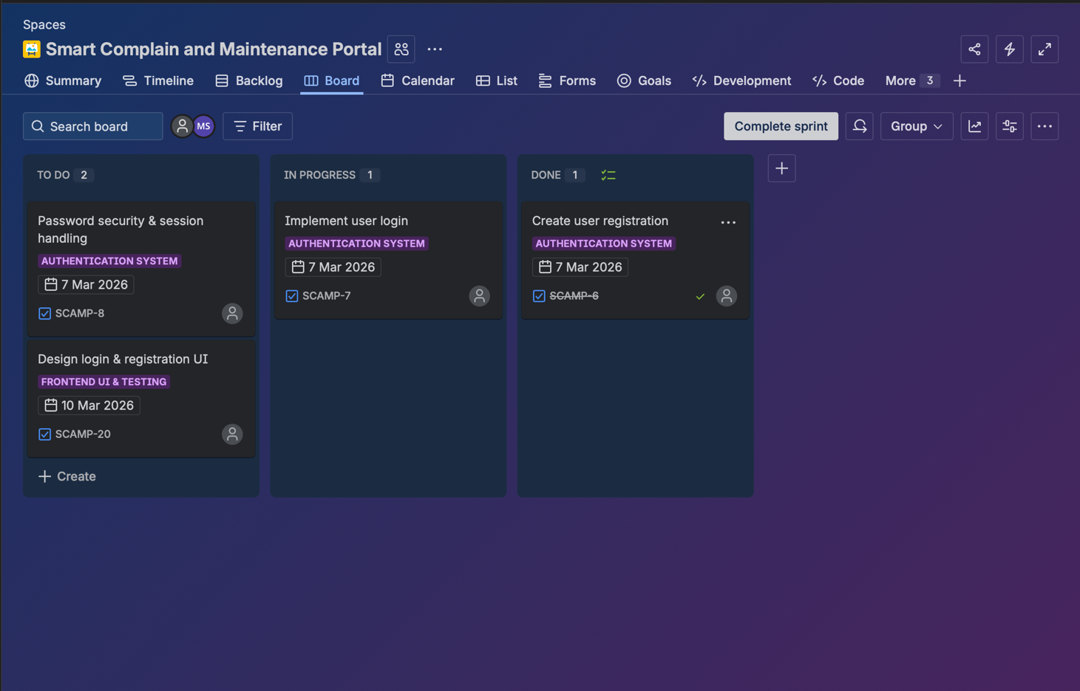

Sprint Planning and Implementation
The development of the Smart Complaint and Maintenance Portal was divided into multiple Agile sprints using Jira to organize and track tasks. Each sprint focused on implementing a specific module of the system.
Sprint 1: Authentication System
In this sprint, the basic user authentication features were implemented. This included user registration, login functionality, and secure access to the system. The login and signup interfaces were also designed.
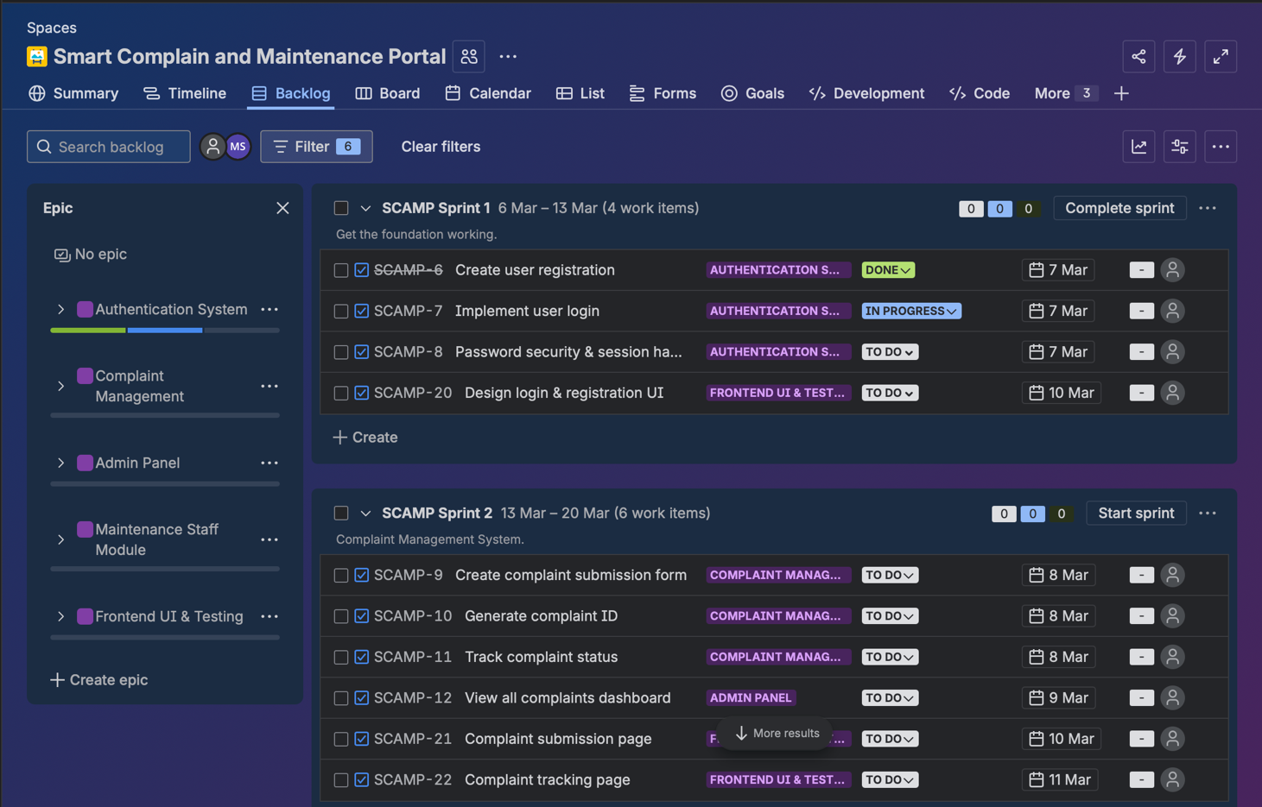

Sprint 2: Complaint Management System
The second sprint focused on developing the complaint submission and tracking features. Users were able to submit complaints, generate complaint IDs, and track the status of their requests through the dashboard.
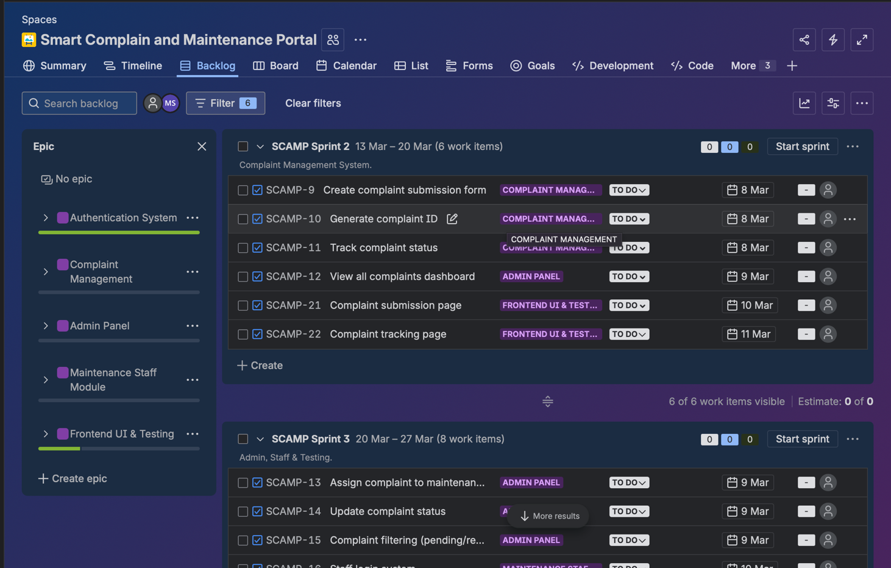

Sprint 3: Technician and Admin Module
The final sprint focused on the administrative and technician functionalities. Administrators could assign complaints to technicians, monitor complaint statistics, and manage the system dashboard. Technicians were able to view assigned tasks, update repair progress, and mark complaints as resolved.
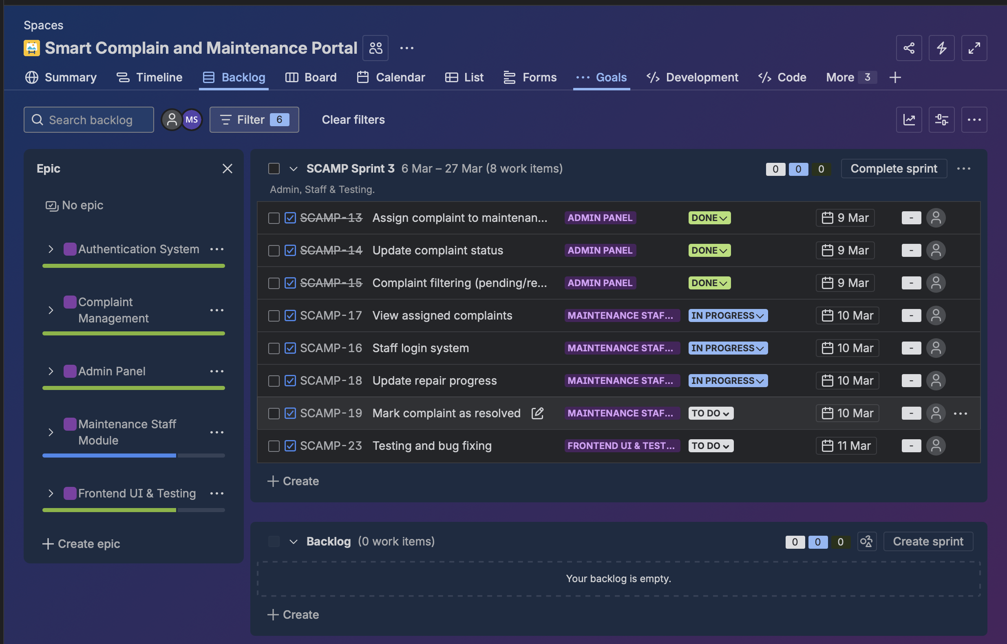
By dividing the project into sprints, the team was able to develop and test features step by step, ensuring better organization and faster development.

DevOps Implementation using Jenkins
To improve development efficiency, Jenkins was used as a Continuous Integration (CI) tool in this project. Jenkins automates the process of building, testing, and monitoring the application whenever changes are made to the code.
In the Smart Complaint and Maintenance Portal project, Jenkins was used to create automated build pipelines. Each time the project was updated, Jenkins triggered a build process and monitored the execution time.
The Jenkins dashboard displayed information such as:
- Build status
- Build history
- Build execution time
- Build time trend
These features helped in identifying errors quickly and ensured that the application remained stable during development.
By integrating Jenkins with the Agile workflow, the development team was able to maintain continuous integration, faster development cycles, and reliable system builds.

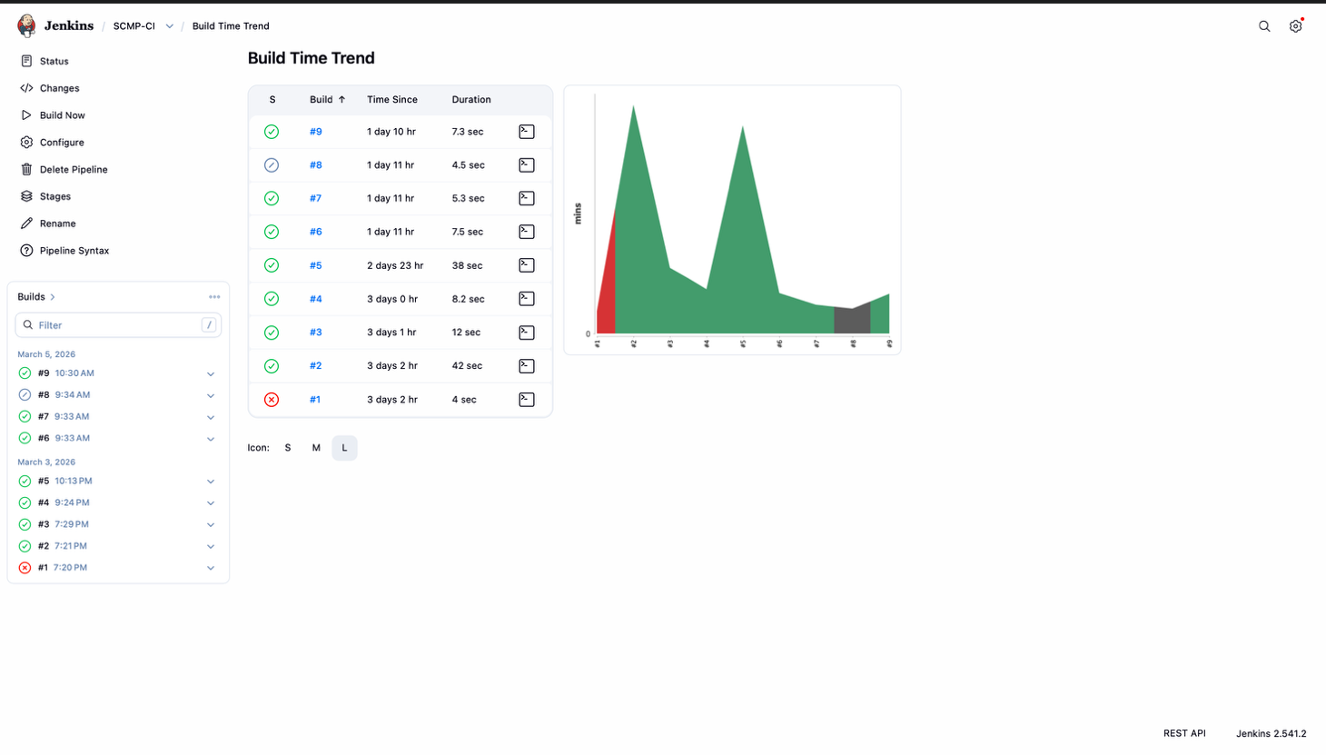

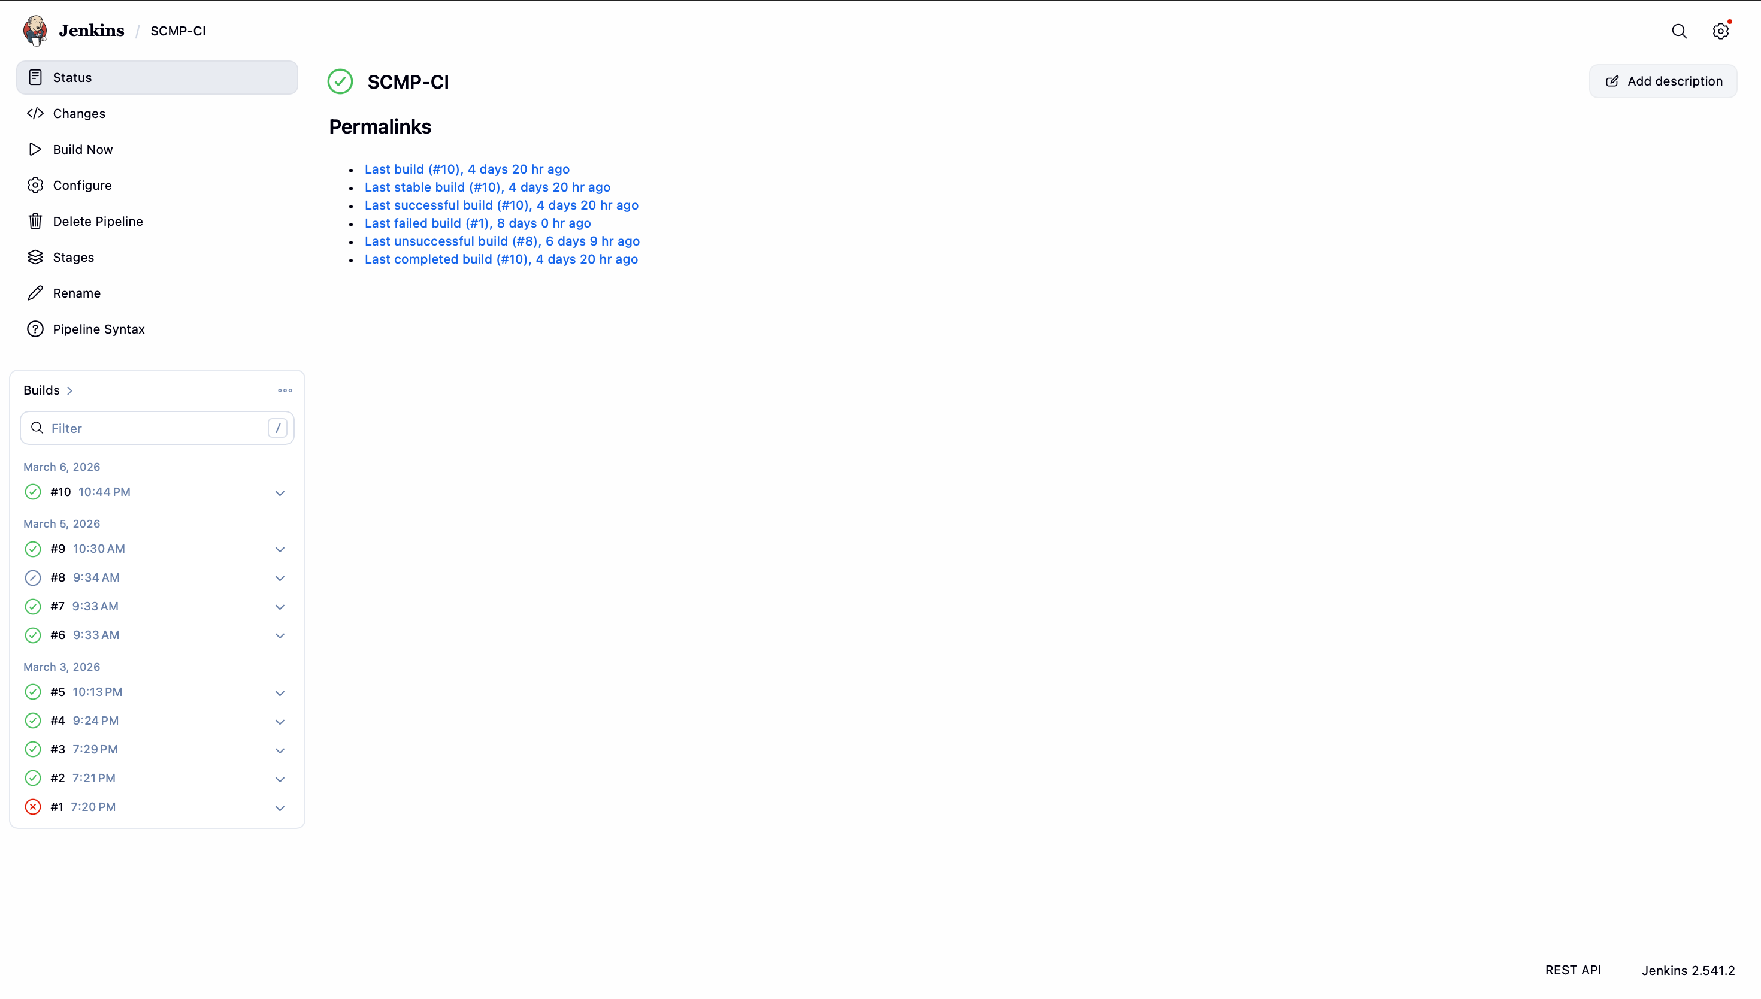

System Architecture
The Smart Complaint and Maintenance Portal follows a simple three-layer architecture consisting of the Frontend, Backend, and Database. This structure ensures efficient communication between users and the system while maintaining organized data management.
Frontend Layer:
The frontend provides the user interface of the portal. It includes pages such as login, complaint submission, user dashboard, technician task board, and admin analytics dashboard. Users interact with the system through these interfaces.
Backend Layer:
The backend handles the core logic of the system. It processes user requests, manages complaint submissions, assigns tasks to technicians, updates complaint status, and controls authentication and authorization.
Database Layer:
The database stores all system data including user accounts, complaint records, technician assignments, and complaint status updates. This ensures that all information is securely stored and easily retrievable.
Together, these layers create a structured system where the frontend communicates with the backend, and the backend interacts with the database to process and store information efficiently.

Key Features of the System
The Smart Complaint and Maintenance Portal includes several important features that help users report issues and allow maintenance staff to resolve them efficiently.
Complaint Submission:
Users can submit maintenance complaints through an online form by providing details such as the issue type, description, and location.
Complaint Tracking:
Users can track the status of their complaints and view updates such as pending, in progress, or resolved.
Technician Task Management:
Technicians can view complaints assigned to them, update repair progress, and mark tasks as completed.
Admin Dashboard:
Administrators can monitor all complaints, assign technicians, and manage system activities from a central dashboard.
Analytics and Reports:
The system provides graphical insights such as complaint status distribution, complaint categories, and average resolution time.
Role Based Access:
The portal supports different access levels for users, technicians, and administrators to ensure proper system control.

Advantages of the System
The Smart Complaint and Maintenance Portal provides several advantages that improve maintenance management and system efficiency.
- Provides a centralized platform for submitting and managing complaints.
- Improves transparency by allowing users to track complaint status.
- Helps technicians manage repair tasks efficiently.
- Reduces delays in complaint resolution.
- Provides analytics and reports for administrators.
- Supports Agile development and CI/CD integration using Jira and Jenkins.
Limitations of the System
Although the Smart Complaint and Maintenance Portal improves maintenance management, it has some limitations.
- The system currently works only as a web application and does not have a mobile app.
- It requires a stable internet connection to access the portal.
- Real time notifications such as SMS or push alerts are not implemented.
- The system currently supports a limited number of users and technicians.
These limitations can be improved in future versions of the system.

Technology Stack
The Smart Complaint and Maintenance Portal was developed using modern web technologies along with Agile and DevOps tools to ensure efficient development and deployment.
Frontend Technologies
- HTML for designing the structure of web pages
- CSS for styling and layout of the user interface
- JavaScript for interactive functionality and dynamic content
Backend Technologies
- Server-side logic to process user requests, manage complaint data, and handle authentication.
Database
- A database system is used to store user information, complaint records, technician assignments, and complaint status updates.
DevOps and Project Management Tools
- Jira was used for Agile project management, sprint planning, and task tracking.
- Jenkins was used for Continuous Integration (CI) to automate build processes and monitor system performance.
These technologies together helped in developing a structured, scalable, and maintainable complaint management system.

Use Case Diagram
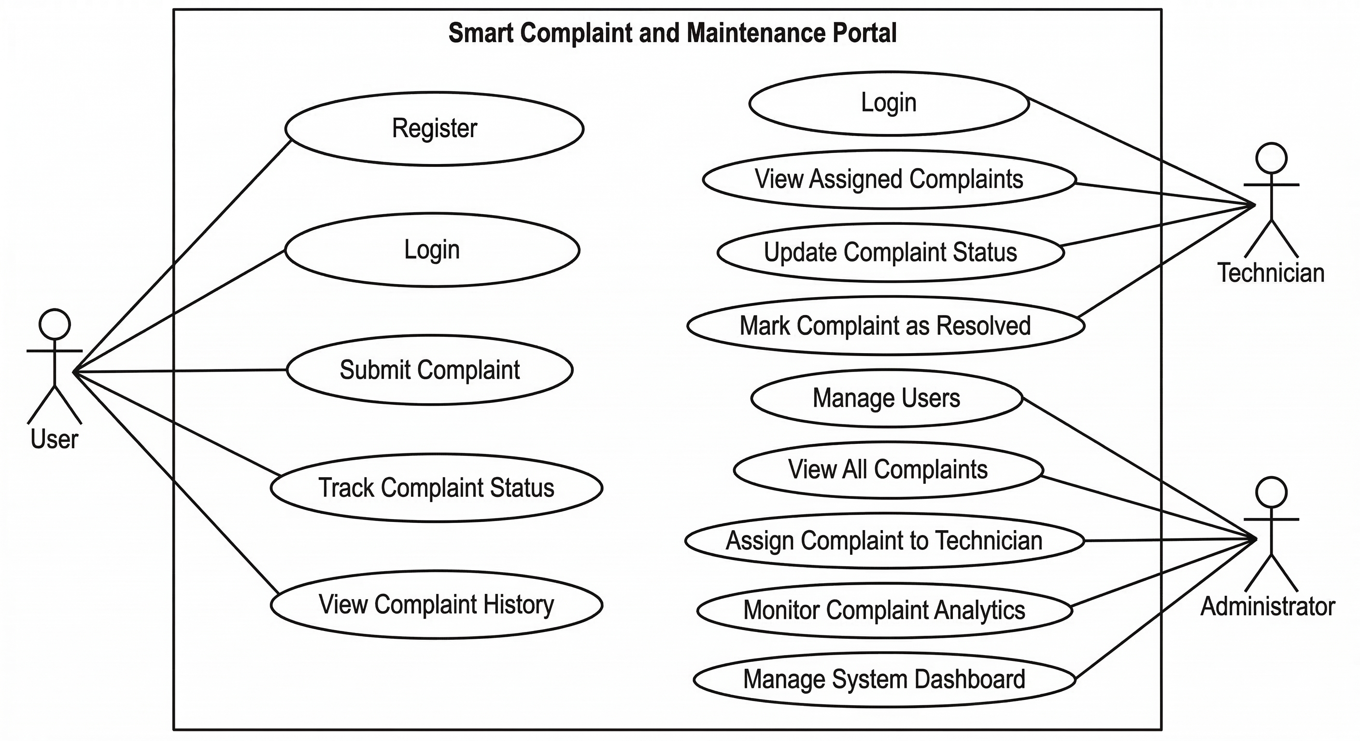
A Use Case Diagram represents how different users interact with the Smart Complaint and Maintenance Portal. It shows the relationship between the system and the actors who use it.
The system mainly has three actors:
User
The user interacts with the system to report and track maintenance issues.
Functions performed by the user:
- Register and login
- Submit a complaint
- Track complaint status
- View complaint history
Technician
The technician is responsible for resolving the assigned complaints.
Functions performed by the technician:
- Login to the system
- View assigned complaints
- Update repair progress
- Mark complaints as resolved
Administrator
The administrator manages the overall system and monitors maintenance activities.
Functions performed by the administrator:
- Manage user accounts
- View all complaints
- Assign complaints to technicians
- Monitor analytics and reports
The Use Case Diagram helps in understanding the interaction between users and system functionalities, making the system design clearer.

Database Design / ER Diagram
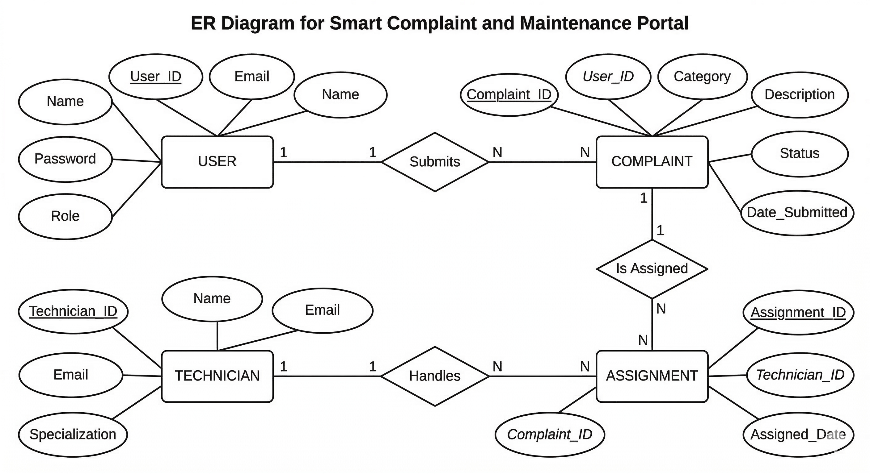
The Entity Relationship (ER) Diagram represents how data is stored and connected inside the Smart Complaint and Maintenance Portal database. It shows the main entities of the system and the relationships between them.
Main Entities
1. User
- User_ID (Primary Key)
- Name
- Email
- Password
- Role
Users can register, log in, and submit complaints.
2. Complaint
- Complaint_ID (Primary Key)
- User_ID (Foreign Key)
- Category
- Description
- Status
- Date_Submitted
Each complaint is created by a user.
3. Technician
- Technician_ID (Primary Key)
- Name
- Email
- Specialization
Technicians are responsible for resolving complaints.
4. Assignment
- Assignment_ID (Primary Key)
- Complaint_ID (Foreign Key)
- Technician_ID (Foreign Key)
- Assigned_Date
This table links complaints with technicians.
Relationships
- User → Complaint
One user can submit multiple complaints.
- Complaint → Technician
Complaints are assigned to technicians.
- Technician → Assignment
One technician can handle multiple complaints.

User Interface Screenshots
This section presents the main interfaces of the Smart Complaint and Maintenance Portal. The screenshots demonstrate how users interact with the system and how administrators and technicians manage complaints.
1. Login Page
The login page allows users, technicians, and administrators to securely access the portal using their credentials.
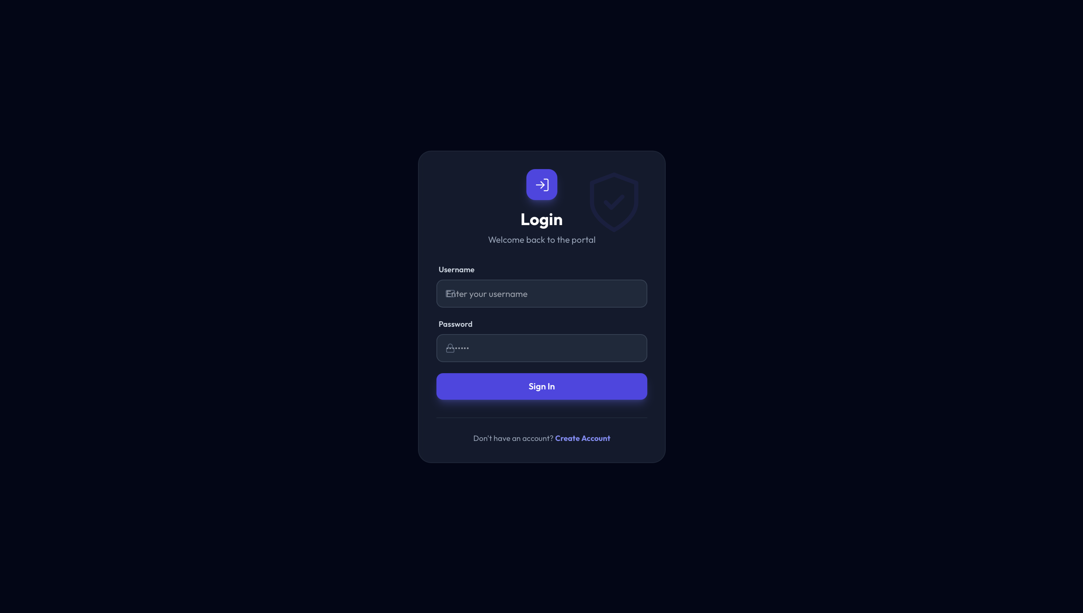

2. User Dashboard
The user dashboard displays an overview of complaint statistics such as total complaints, pending complaints, and resolved complaints. It also provides quick access to submit a new complaint.
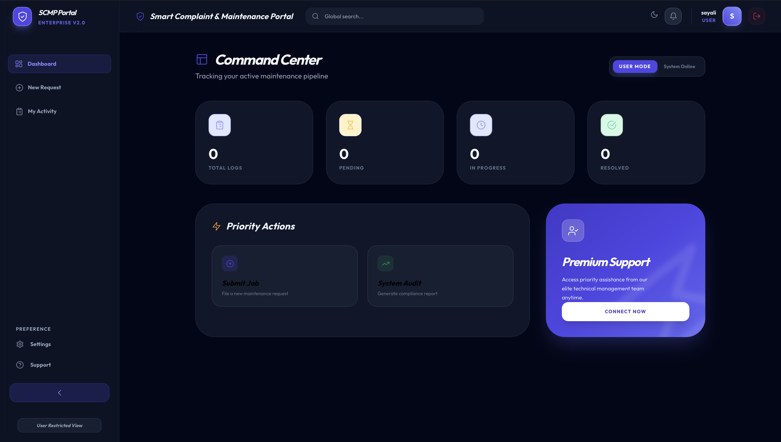
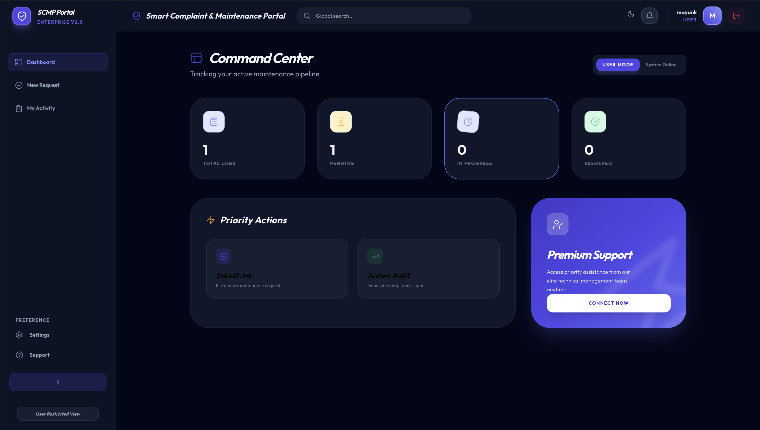

3. Complaint Submission Page
This page allows users to submit a new maintenance complaint by entering details such as the complaint category, description, and location.
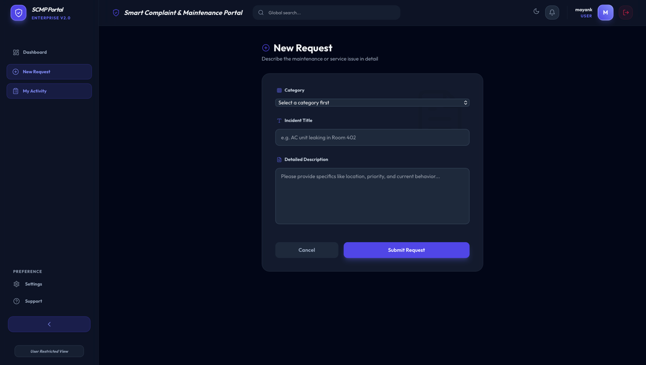

4. Complaint Tracking Page
Users can track the progress of their complaints and view status updates such as pending, in progress, or resolved.
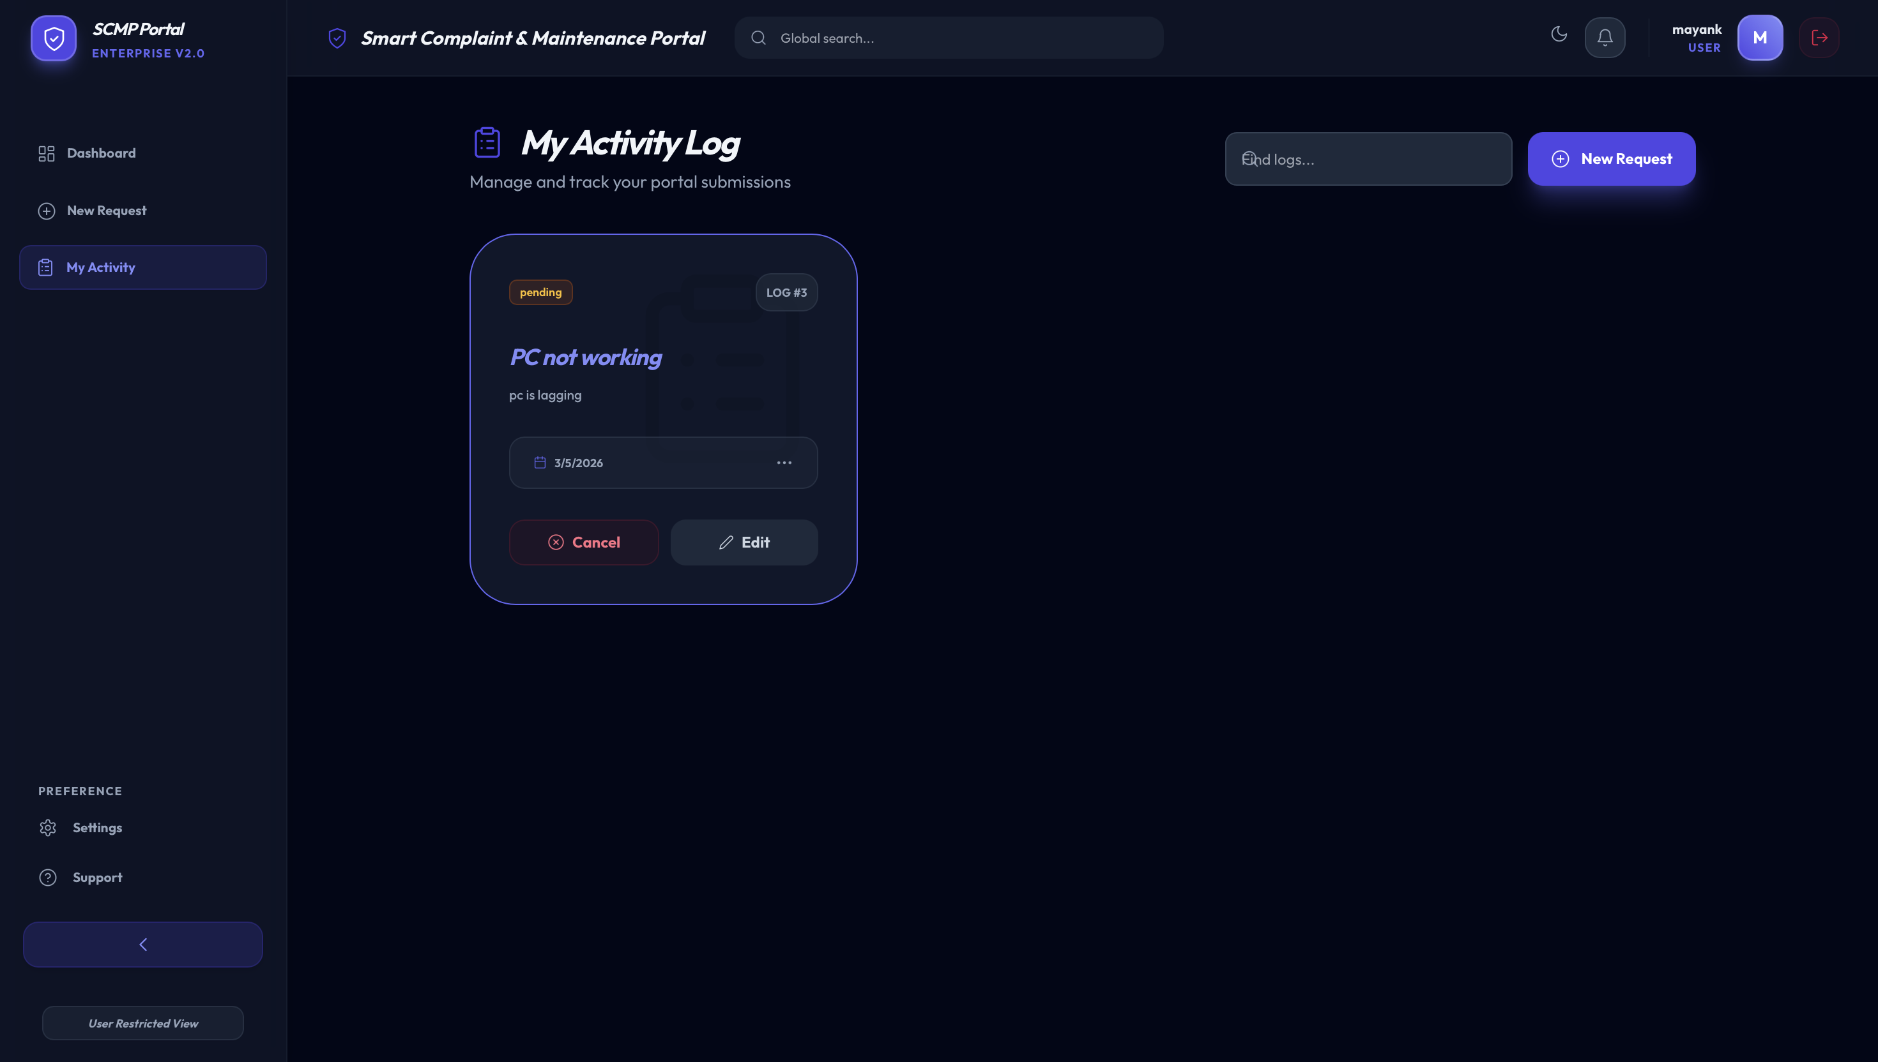

5. Technician Task Board
The technician dashboard shows all assigned complaints. Technicians can update repair progress and mark tasks as completed.
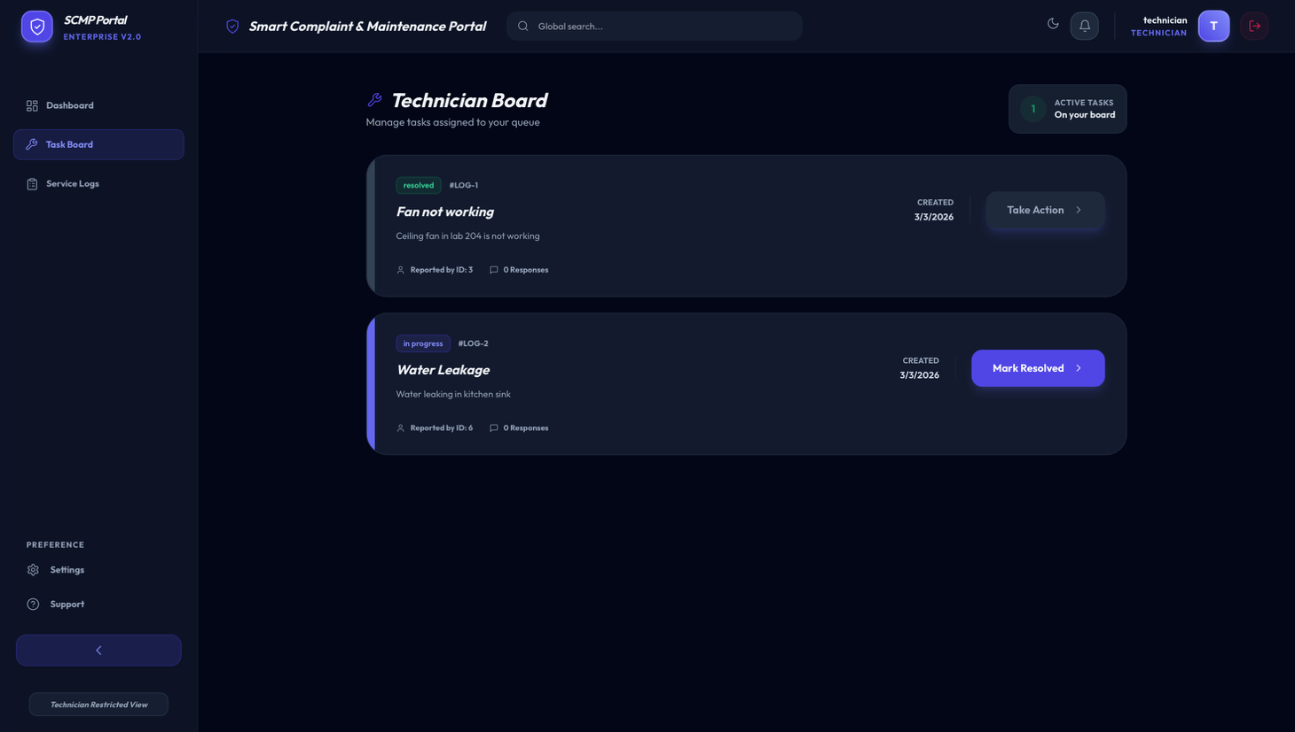
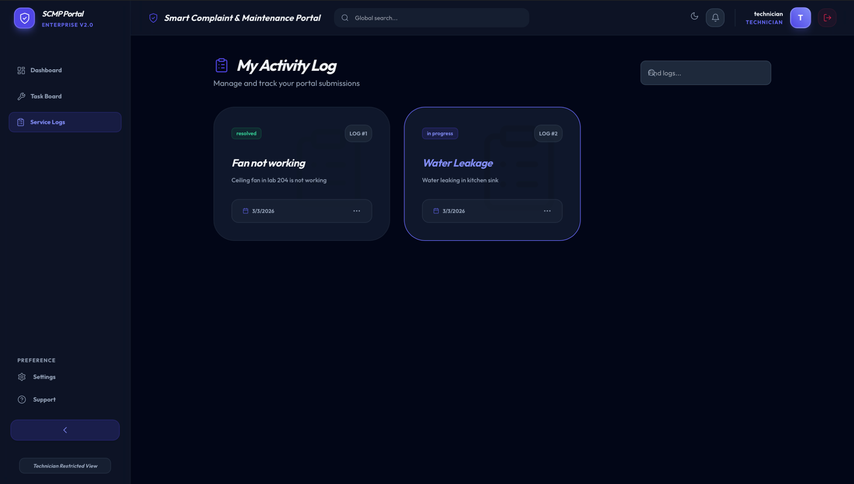

6. Admin Analytics Dashboard
The administrator dashboard provides system insights including complaint distribution, resolution statistics, and system activity logs.

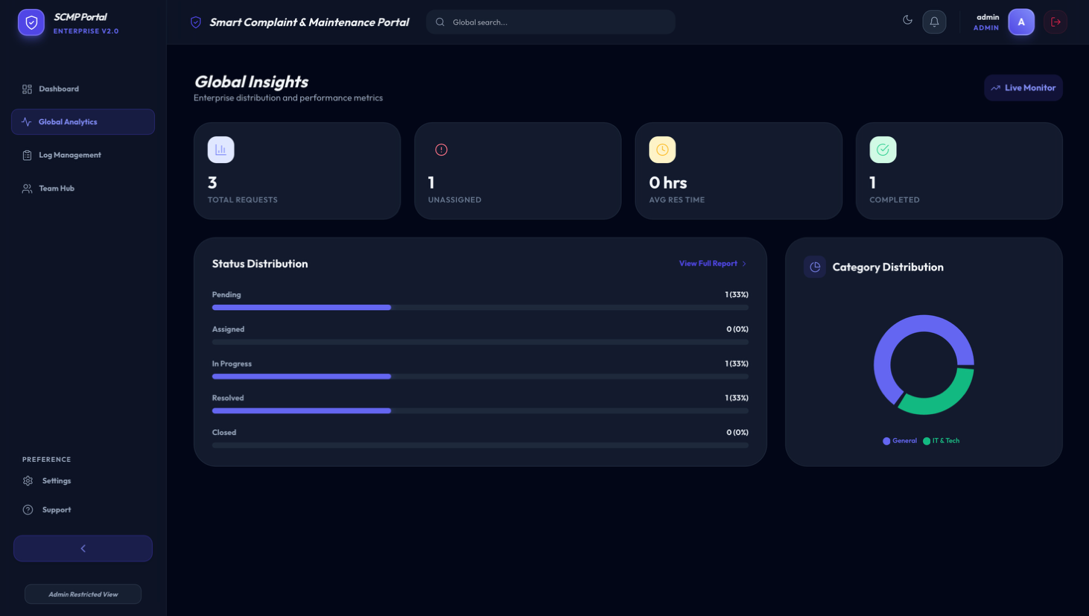
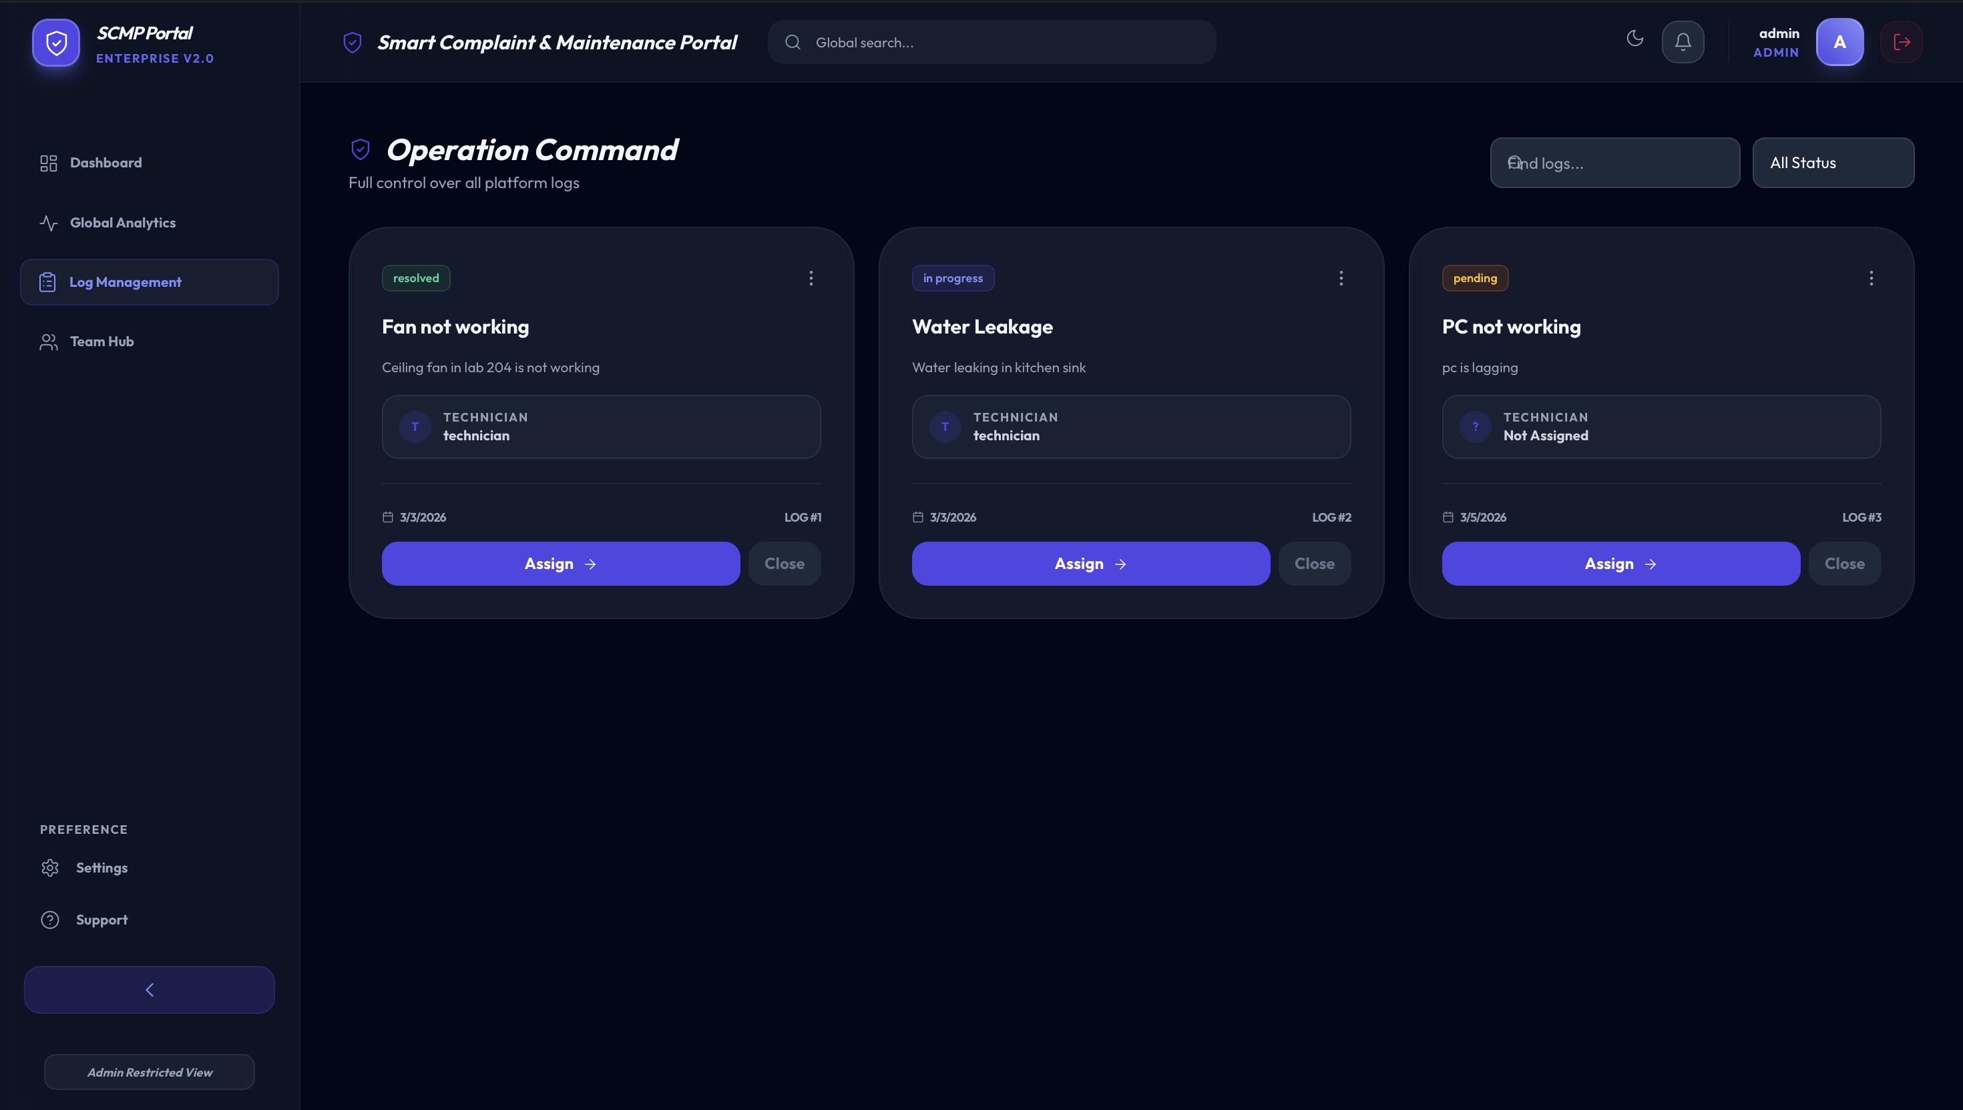

7. Jira Sprint Board
The Jira board displays Agile sprint planning and task tracking using columns such as To Do, In Progress, and Done.
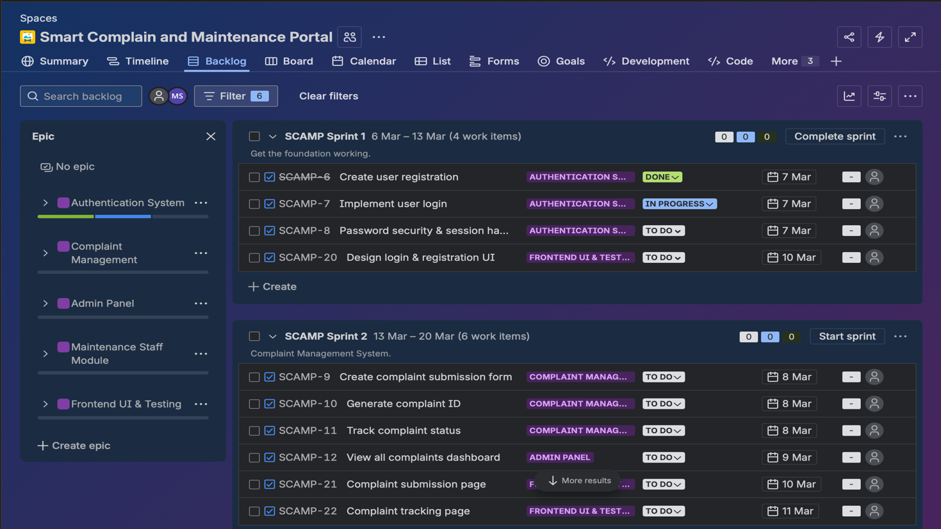
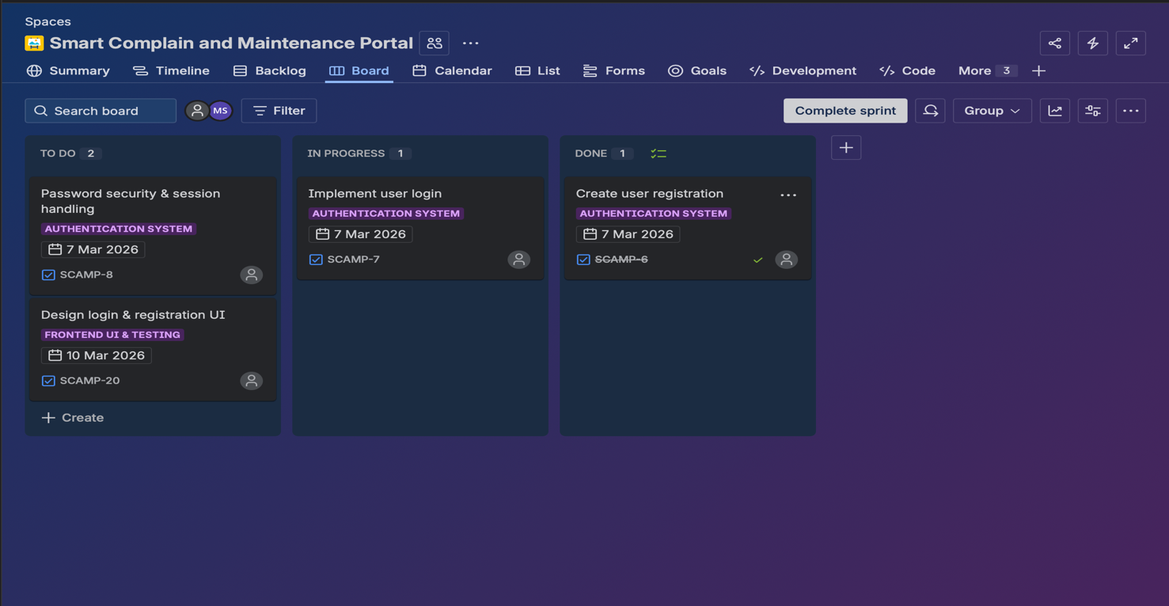

8. Jenkins CI Dashboard
The Jenkins dashboard shows automated build pipelines, build status, and build time trends used for continuous integration.


Testing
Testing was performed to ensure that the Smart Complaint and Maintenance Portal works correctly and provides a smooth user experience. Different types of testing were carried out to verify system functionality and reliability.
Functional Testing
Functional testing was conducted to verify that all system features work as expected. This included testing user registration, login functionality, complaint submission, complaint tracking, technician task updates, and admin complaint management.
User Interface Testing
The user interface was tested to ensure that all pages load correctly and that users can easily navigate through the portal. Forms, buttons, and dashboards were tested for proper interaction.
Integration Testing
Integration testing ensured that different modules of the system work together properly. For example, when a user submits a complaint, the complaint is stored in the database and becomes visible to the administrator and technicians.
CI Pipeline Testing
The Jenkins Continuous Integration pipeline was tested to ensure that automated builds run successfully and detect issues during development.
Through these testing processes, the system was verified to operate correctly and provide reliable complaint management functionality.

Future Enhancements
The Smart Complaint and Maintenance Portal can be further improved by adding new features and technologies to enhance system efficiency and user experience.
- Development of a mobile application for easier access to the portal.
- Implementation of real-time notifications through email or SMS when complaint status changes.
- Integration of AI-based complaint prioritization to automatically identify urgent maintenance issues.
- Addition of location-based complaint tracking for faster technician assignment.
- Integration with IoT devices to detect maintenance problems automatically.
- Implementation of advanced analytics dashboards for better decision making.
These enhancements would improve the functionality, scalability, and usability of the system in future versions.

Conclusion
The Smart Complaint and Maintenance Portal successfully demonstrates the development of a centralized system for managing maintenance complaints efficiently. The platform allows users to submit complaints, technicians to handle repair tasks, and administrators to monitor overall system performance through dashboards and analytics.
The project was developed using Agile Product Development methodology, where tasks were organized into sprints using Jira for better planning and tracking. In addition, Jenkins was integrated to implement Continuous Integration (CI), enabling automated builds and improving development efficiency.
By combining Agile practices with DevOps tools, the system ensures faster development cycles, improved collaboration, and reliable system performance. The portal provides a structured and transparent approach to complaint management and can be further enhanced with additional features in the future.
Overall, the Smart Complaint and Maintenance Portal offers a practical solution for efficient maintenance management while demonstrating the effective use of Agile and DevOps practices in modern software development.

